San José State University

Department of Computer Engineering

**CMPE 280**

Section 4

**Web UI Design and Development**

Fall 2017

**Assignment 1 - Functional specification**

**Team**: Knights of 280

Arpita -

Ipsha -

Khoa Le - 009301968

**Product Name**

AmazingChef

**Problem Statement**

People don’t have enough cooking knowledge to decide what to cook with few ingredients they have.

**Product Objectives**

AmazingChef is a recipe search engine that helps people find recipes based on the ingredients. Customers can set filters based on your cook time, cuisine type, meal type, dietary restrictions to refine search result.

**Functional requirements**

1. Add/Remove ingredients
2. Search a recipe
3. Setup Filter (cook time, cuisine, meal type, dietary restriction)
4. Add comments/reviews on recipes
5. Reset search
6. Save a recipe (export to pdf, text, or else)

**Non Functional requirements**

1. The application must respond to user input within 5 seconds
2. The application shall run on the Google Chrome browser
3. The application must have default options (for example cook time is default to 20 mins)
4. The application must be accessible to unregistered users

**Use Cases Diagram**

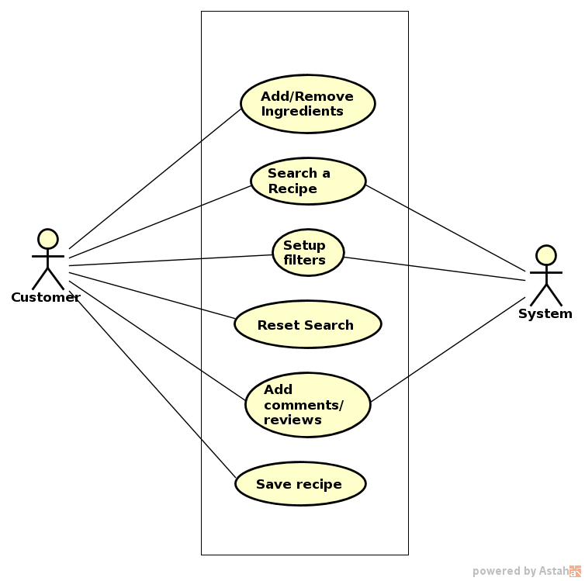

**Use Case Description**

1. Search a recipe
2. Setup Filter
3. Add comments/reviews on recipes